HERDING CAPABILITY TEST

HERDING TRIAL

&

ARENA TRIAL

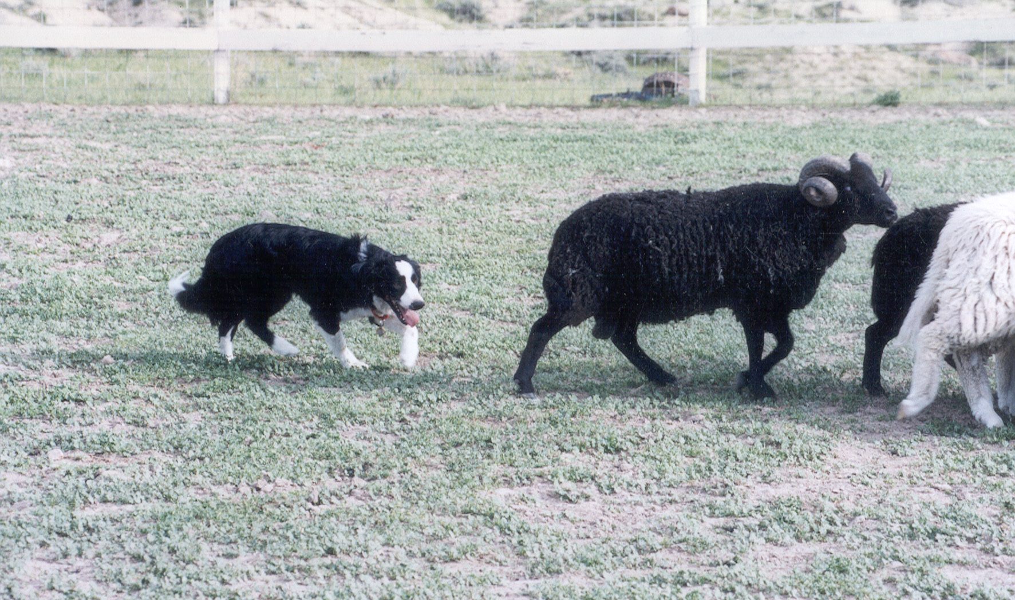

August 13, 2005

LOCATION:

Myron Lindgren Farm - Scandia, MN

ENTRY FEES ALL CLASSES:
PRE-ENTRY (Due August 1, 2005) $25/run Day-Of (livestock available) $30/run

MAIL ENTRIES TO:
JoAnna Yund
4047 Sheridan Ave. So.
Minneapolis, MN 55410
JoAnnaY@aol.com

HERDING CAPABILITY TEST

HERDING TRIAL

&

ARENA TRIAL

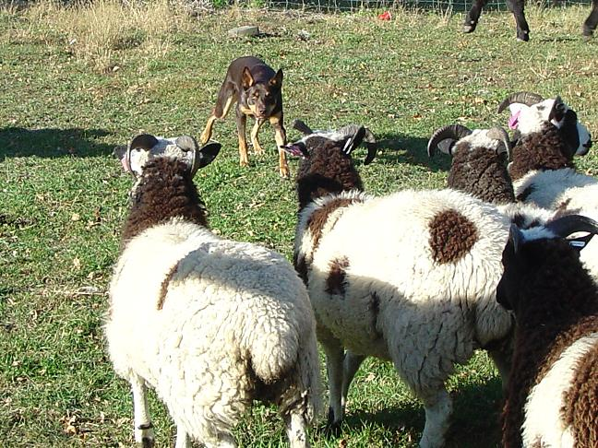

August 13, 2005

LOCATION:

Myron Lindgren Farm - Scandia, MN

ENTRY FEES ALL CLASSES:
PRE-ENTRY (Due August 1, 2005) $25/run Day-Of (livestock available) $30/run

MAIL ENTRIES TO:
JoAnna Yund JoAnnaY@aol.com
4047 Sheridan Ave. So.; Minneapolis, MN 55410

